***PUBLIC TRANSPORT OPTIMIZATION USING IOT***

***Phase_4***

**INTODUCTION:**

**Project Overview:**

It is a a cutting-edge project that leverages the internet of things (IOT) technology to enhance the efficiency,safety and convenience of public transport system.The Real-Time Transit Information Platform is a web-based application designed to display simulated real time transit data for a fictional transit station. This documentation provides an overview of the project, its objectives, and the technologies used.

**Objectives:**

Simulate real-time transit data updates for a functional station.

Demonstrate the use of web development technologies (HTML,CSS,Java Script) to create a dynamic platform.

**HTML STRUCTURE (INDEX.HTML):**

The index.html file serves as the entry point for the application.

**Code explanation:**

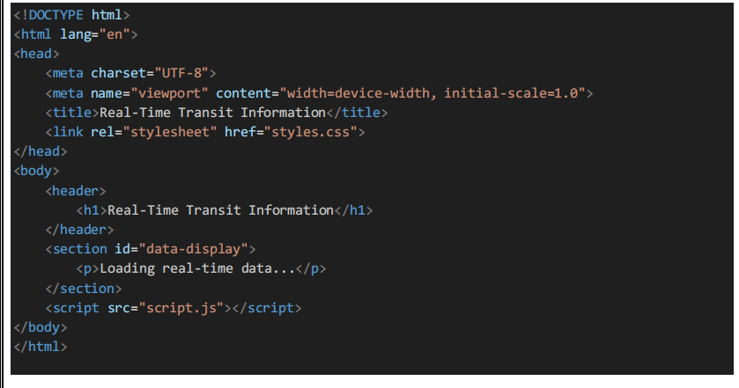

**JAVA SCRIPT LOGIC (SCRIPT.JS)**

The script.js file contains java script code that simulates real time data updates.

**Code explanation:**

**3**

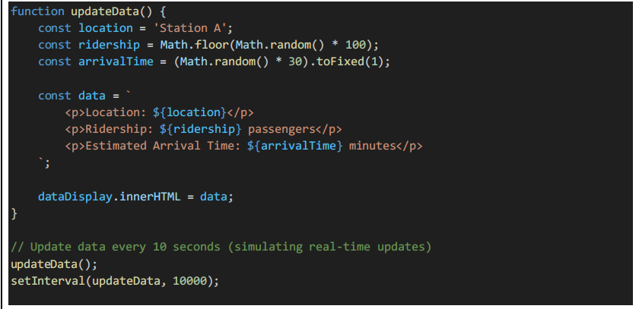

**CSS STYLING(SSTYLES.CSS):**

The styles.css file provides styling for the web page.

**Code Explanation:**

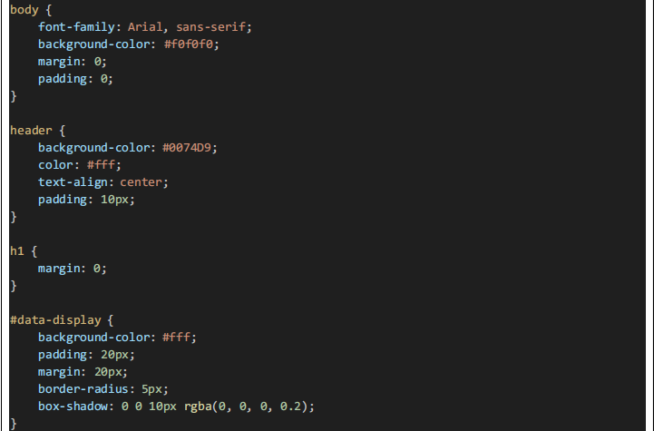

**PROJECT ARCHITECTURE**

**High-Level Overview**

The project consists of a simple web page with HTML,CSS and JAVA SCRIPT for the front end.It simulates real time data updates without the use of actual IOT sensors. The data is generated and displayed on the page.

**Data Flow**

Data is generated and updated in real time using java script. The front end receives data updates and displays them in the designated section.

**REAL-TIME DATA SIMULATION**

**Data Source**

The project simulates data for a fictional transit station.Data source are not real IOT sensors but generated within the JavaScript code.

**Data Generation Logic**

Data is generated with random values for location , ridership and estimated arrival time .

**Real-Time Updates**

The java script code simulates real-time updates by refreshing data every 10 seconds.

**USER INTERFACE:**

The user interface includes a header and a data display section , styled using CSS.

**TESTING :**

The project is displayed by opening the index.HTML file in the web browser . Real-Time data updates are simulated , and you can observe the changes.

**DEPLOYMENT:**

The project is deployed as a static website , and it can be hosted on any web server or platform capable of serving HTML,CSS and JavaScript files.

**OUTPUT:**

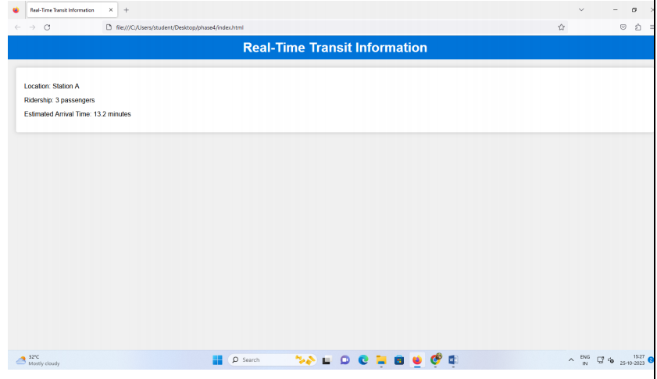

**CONCLUSION :**

This platform is a simple example of using web development technologies to simulate and display real-time data updates. It serves as a basic educational resource for understanding how real-time data can be presented in a web application.